**Lecture Sheet**

**On**

**Basic Concepts of Algebra**

Md. Mohiuddin

Lecturer

Department of Mathematics

Comilla University, Cumilla-3506

Email: mohi.in2012@gmail.com

**Equation:** An equation is a mathematical statement, which defines the equality of two expressions connected by an equal sign “=”. The most common type of equation is an algebraic equation containing one or more variables (unknown).

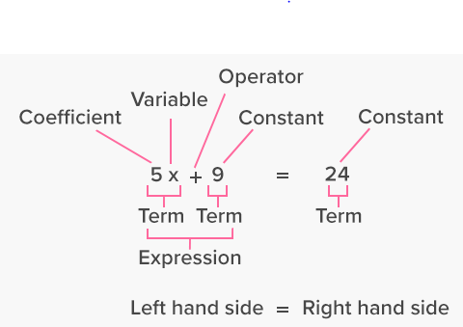For instance,  is an equation, in which  and 6 are two expressions separated by an ‘equal’ sign. In an algebraic equation, the left-hand side is equal to the right-hand side.

Solving an equation containing variables determines the values of the variables which make the equality true and these values are called the solutions of the equation.

There are two kinds of equations such as:

1. **Identity:** An identity is an equation that is always true for any value substituted into the variable. For example,  is an identity.
2. **Conditional equation:** A conditional equation is an equation that is only true for particular values of the variables. For example,  is a conditional equation.

**Algebraic Expression:** An algebraic expression is a combination of integer constants, variables, exponents and algebraic operations such as addition, subtraction, multiplication and division. 5*x*, *x* + *y*, *x*-3 and more are examples of algebraic expression.

**Binary Relation:** A binary relation R between sets A and B is a subset of the Cartesian product . Suppose  and . Further suppose . This is a subset of so it is a binary relation between A and B.

**Relation:** A relation R consists of the following:

1. a set A
2. a set B
3. an open sentence P(*x*, *y*) in which P(a, b) is either true or false for any ordered pair (a, b) belonging to .

We then call R a relation from A to B and denote it by

.

Furthermore, if P(a, b) is true we write



which reads “ a is related to b”. On the other hand, if P(a, b) is not true we write



which reads “ a is not related to b”.

Example: 1. Let  where , , and  reads “ *x* divides *y*”. Then the solution set of R is

.

Example: 2. Let  where A is the set of men, B is the set of women, and reads “ *x* is the husband of *y*”. Then R is a relation.

Example: 3. Let  where A is the set of men, B is the set of women, and reads “ *x* divides *y*”. Then R is not a relation a relation since P(a, b) has no meaning if a is a men and b is a women.

**Inverse Relation:** Every relation R from A to B has an inverse relation  from B to A which is defined by

.

In other words, the inverse relation  consists of those ordered pairs which when reversed, i.e. permuted belong to R.

Example: Let  and . Then is a relation from A to B. The inverse relation of R is .

**Reflexive Relation:** Let  be a relation in a set A, i.e. let R be a subset of . Then R is called a reflexive relation if, for , . In other words, R is reflexive if every element in A is related to itself.

Example: Let and . Then R is not a reflexive relation since (2, 2) does not belong to R. Notice that all ordered pairs (a, a) must belong to R in order to R to be reflexive.

**Symmetric Relation:** Let R be a subset of , i.e. let R be a relation in A. Then R is called a symmetric relation if implies  that is, if a is related to b then b is related to a.

Example: Let and . Then R is not a symmetric relation since but .

**Anti-symmetric Relation:** Let R be a subset of , i.e. let R be a relation in A. Then R is called an anti-symmetric relation if and implies . In other words, if  then possibly a is related to b or possibly b is related to a, but never both.

Example: Let and . Then R is not an anti-symmetric relation since  and .

**Transitive Relation:** Let R be a subset of , i.e. let R be a relation in A. Then R is called a transitive relation if and  implies . In other words, if a is related to b and b is related to c, then a is related to c.

Example: Let and . Then R is not a transitive relation since and but .

**Equivalence Relation:** Let R be a subset of , i.e. let R be a relation in A. Then R is called an equivalence relation if

1. R is reflexive, that is, for every, .
2. R is symmetric, that is, implies .
3. R is transitive, that is, , and  implies .

Example: The most important example of an equivalence relation is that of “equality”. For any elements in any set:

1. .
2. implies .
3. and implies .

**Function:** If a variable *y* depends on a variable *x* in such a way that each value of *x* determines exactly one value of *y*, then *y* is called a function of *x* and it is denoted by the following symbol,



where *x* is independent variable and *y* is dependent variable. The inverse of this function is denoted by .

Example: $y=x^{2}+x+1$; $y=sinx$; $y=e^{x}$; $y=lnx$ etc.

Alternatively, let  and  be two non empty sets. A mapping is called function if each element of  is assigned by unique element of .

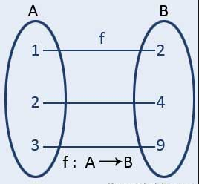 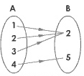 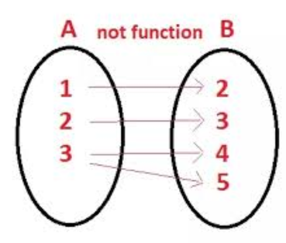

Function Function It is not function

**Types of functions:** There are many types of functions. These have been discussed as:

**Even function:** A function $y=f(x)$ is called an even function if it satisfies the condition

$f(-x)=f(x)$.

Example: $y=cosx, y=x^{4}, etc.$ are even functions.

**Odd function:** A function $y=f\left(x\right)$ is called an odd function if it satisfies the condition

$f\left(-x\right)=-f(x)$.

Example: $y=sinx, y=x^{3}, etc.$ are odd functions.

**One–one Function:** Let  map  into , i.e, . Then  is called a one-one function if different elements in  are assigned to different elements in , that is, if no two different elements in  have the same image. More briefly,  is one-one if  implies or, equivalently,  implies .



**Onto Function:** Let  be a function of into . Then  is called a onto function if every element of  appears as the image of at least one element of . More briefly,  is onto function if .



**Constant Function:** A function  of into is called a constant function if the same element in  is assigned to every element in . More briefly,  is a constant function if the range of  consists of only one element.

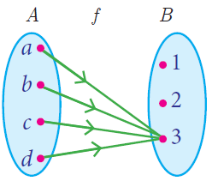

**Inverse Function:** Let  be a function of into . In general,  could consist of more than one element or might even be the empty set . Now if  is a one-one function and an onto function, then for each  the inverse  will consist of a single element in . We therefore have a rule that assigns to each  a unique element in . Accordingly,  is a function of  into  and we can write



In this situation, when  is one-one and onto, we call  the inverse function of .

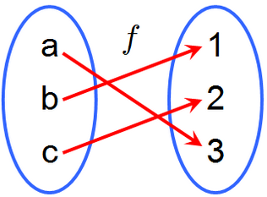 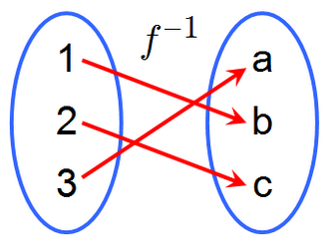

Function,  Inverse function, 

**Real number:** Numbers are the foundation of Mathematics. The most common numbers in Mathematics are the real numbers. These numbers are closed under the operations addition and multiplication. The set of rational and irrational numbers is called the set of real number and it is denoted by .

**Properties of real numbers:** For all real numbers , , and  the following properties hold:

1. Closure properties: and  are real numbers.
2. Commutative properties:  and .
3. Associative properties:  and .
4. Distributive properties: .
5. Identity properties: There exists a unique real number 0 with respect to addition such that .

There exists a unique real number 1 with respect to multiplication such that .

1. Inverse properties: There exists a unique real number – a such that  and .

If , there exists a unique real number .

In general, any set which satisfy above conditions is called a field.

**Complex number:** Any number of the form, whereand, is called a complex number and it is denoted by.

i.e. 

In complex number *z*, *x* is the real part of *z* denoted by the symbol  and *y* is the imaginary part of *z* denoted by the symbol and also  is called imaginary unit. Geometrically, a complex number represents a unique point in the complex plane/Argand Plane/Argand diagram/Gaussian Plane. Also geometrically,  is the projection of on to the *x* axis, and  is the projection of *z* on to the *y* axis.

**O**

**X’**

**Y**

**Y’**

**X**



**Properties of complex numbers:** If , ,  belong to the set  of complex numbers, the following properties hold.

1.  Closure law
2.  Commutative law of addition
3.  Associative law of addition
4.  Commutative law of multiplication
5.  Associative law of multiplication
6.  Distributive law
7. is called the identity with respect to addition, 1 is called the identity with respect to multiplication.
8. For any complex number  there is a unique number in  such that ; is called the inverse of  with respect to addition and is denoted by .
9. For any there is a unique number in  such that ; is called the inverse of with respect to multiplication and is denoted by .

In general, any set which satisfy above conditions is called a field.

**Conjugate of complex number:** The conjugate of a complex number  is obtained by changing the sign of *y* and is denoted by the symbol  i.e. .Geometrically, the conjugate of a complex number represents the reflection or image of the complex number *z* about the real axis *x*.

P( x , y)

**X’**

**Y**

**Y’**

**X**

**O**

P’( x, -y)